Sela
TalkBack
Chat and Backgammon
Messaging program
SRS

Table of Contents
1. Introduction 4
1.1. Purpose and Overview 4
1.2. Terms and Abbreviations 4
1.3. Referenced documents 4
2. Functional Requirements 5
2.1. Presentation layer 5
2.1.1 Application main window 5
2.1.2 Sign-in page 5
2.1.3 Contact pane 5
2.1.3.1 Chat pane 6
2.1.3.2 Contact pane “wide mode” 7
2.1.4 Game pane 7
2.2 Application layer 8
2.2.3 Client requests and reactions to responses 8
2.2.3.1 Sign-up request 9
2.2.3.2 Sign-in / sign-out request 9
2.2.3.3 Game request 9
2.2.3.4 Message request 9
2.2.3.5 In-game requests 10
2.2.4 Push messages from the server 10
2.2.5 Server requirements 11
2.2.5.1 Overview 11
2.2.5.2 Sign on / sign off responses 11
2.2.5.3 Chat response 11
2.2.5.4 Backgammon request 11
2.2.5.4.1 Specific contact request 11
2.2.5.4.2 Random contact (or computer) request (In future version) 12
2.3 Reports 12
3 System Architecture 13
3.1 Overview 13
3.2 System Architecture Diagram 13
4 TalkBack Server Requirements 14
4.1 Overview 14
5 Non-functional Requirements 15
5.1 Data Management 15
5.2 Performance 15
5.3 Security 15
6 Technical Implementation Aspects 16
6.1 System Configuration 16
6.1.3 Client Platform 16
6.1.4 Application Server Configuration 16
6.1.5 DB Server 16
6.2 Development Platform 16
7 GUI Requirements Specification 17
7.1 Taskbar icon 17
7.2 Sign-in page 18
7.3 Menu options: 20
7.4 Contact pane 21
7.5 Chat pane 23
7.6 Game pane 24
7.7 Cntact pane “narrow mode” 26

Introduction

Purpose and Overview
This document specifies the System Requirements for the TalkBack system, which is a web-service based messaging system, which enables users to chat with each other and / or play backgammon against each other (or against the computer).

Terms and Abbreviations

GUI | Graphical User Interface
HW | Hardware
OS | Operating system
SW | Software
TBD | To Be Defined

Referenced documents
none

Functional Requirements
TalkBack is a messaging system which provides users with the ability to chat with each other and/or play backgammon against each other. The system is comprised of clients who connect to a central application server, this allows them to see who is online, and to choose whom to talk to or play backgammon against.

Presentation layer
This section specifies the functionality of the GUI layer of the system by describing the functionality of the client. Detailed GUI layout is specified below in a separate section.

2.1.1 Application main window
The main page of the application should have the title and menu button as detailed in section 7.2 below. Upon opening the application, this page will have the format of the "sign-in screen", and upon logging in – change to the "contact screen". It should remain this way until the user signs out, and then it should change back to the sign-in screen.
The title and the menu functions should stay the same on both screens. (Menu functions are detailed in section 7.2 below.)

2.1.2 Sign-in page
The header should display a welcome message. Below this will be the sign-in area.
The sign in area includes fields for name and password and a button for submitting.
First time activation: When opening the application for the first time, the user must choose his sign-in name and password, enter them and connect to the service. Once the connection is completed, this page will change to the client's main page, which will be called "contact screen".
If the connection fails, the user should be presented with an appropriate message.
The application should remember the sign-in name for the next time the user signs in, and suggest it to him whenever the client is launched.

Contact pane
Here the user sees his list of contacts and their statuses – are they currently connected or not. In this version of the application, whoever signs-up to the service and successfully registers on the server is automatically included in the other users' contact lists.

When the user sign-up for the first time, the client displays this page and shows a "connecting…" message, while it receives the list of contacts from the server. Now the list of contacts should appear on the user's contact list.
When an existing user signs-in, the page should display the entire list of contacts, all in offline mode, and a "connecting…" message. When connection is complete, the status of those contacts that are online should change, and they should appear in the "online contact" section.

The user can choose to communicate with any online contact in one of the following ways: Chat or play Backgammon.
- Chat – the user double-clicks the contact name or selects the contact and then presses the chat button. When doing so, a chat pane will open to the right, in which the user can chat with the contact.
- Play Backgammon – if the user selects the contact name and presses the "game" button, a popup window with a "wait for connection…" message should appear, while waiting for the contact to accept the match proposal.
If the contact confirms, a separate "game pane" will be displayed on the left, in which the game shall be played. The contact pane will change in to “narrow mode” and will move to the right side
In event the contact declines the request to play, the client of the initiating user shall display a "sorry, you request has been refused" message to the user.
In future version:
In event that no contact has been highlighted, then the server will attempt to find a random contact to play against (for this to happen, a different user must also be looking for a random player to play with).
- If a user is found within the next 15 seconds, the application should launch the "game page" and start the game against this contact.
- If no user is found to within the allotted time, the application will launch the "game page" and notify the user he will be playing against a computerized opponent. The application will then make the moves for the opponent, according to an algorithm programmed into it.

Chat pane
The screen should be divided into two panes: the upper part has the chat history, and the lower part is the editing area, where the user composes and sends his messages.
This pane is displayed in two ways:
- The user selects a contact to chat with. In this case the pane will be empty when displayed.
- A contact initiates a chat with the user. In this case the pane will appear with the contents of the contact's message in the history pane. The application should also emit some kind of sound to notify the user of the incoming message.
After the user composes a message and sends it, the message will disappear from the lower part and appear in the upper part of the pane.
If the message wasn't received successfully by the recipient, the application should show a "Your message wasn't sent successfully" warning beneath the sent message in the chat history pane.
All messages should appear - in the order they were sent - in the history pane.
Play Backgammon – if the user presses the "game" button in this screen, a popup window will be displayed, while waiting for the contact to confirm he's interested in playing. If the contact confirms, the "game pane" will be displayed. If not, the user will be displayed with a message, and a button to close this popup.
Obviously, the only possibility here is to play against the contact the user is chatting with, and not a random contact.

Contact pane “wide mode”
When no game is in progress, the contact pane will take on the whole page. The page will be split in to two panes, the contact pane which will be displayed on the left and the chat pane on the right.
      - Contact pane “narrow mode”
When a game is in progress, the contact pane will change in to “narrow mode” and appear only on the right side. When in “narrow mode” contact pane will have the list contacts in a drop down box , when the difference between connected and un connected will be shown by an icon. Below the drop box the chat pane will remain the same, when selecting a contact in drop box behavior wil be the same as on selecting in “wide mode”

Game pane
This pane is displayed only after the contact has confirmed he wishes to play, or when the client will simulate a computerized player to play against the user.
This pane should show a standard backgammon board, as detailed below (in section 7.5). The user should see his name near the lower side of the board, and the contact's name near the upper side. Buttons are available for rolling dice or resigning the game. There should also be a button for undoing the last move.
The rules of backgammon are known, and a tutorial can be found in the menu button, under: menu>Help > How to play Backgammon.
The program should offer each side to roll one die to see who begins. The one who gets the higher number goes first (in case of a tie, each player rolls again).
All other turns begin with the conclusion of the other player's turn. From the moment each player's turn begins, he has 2 minutes to roll the dice and make his moves. If he doesn't move within this time, he forfeits the game and the other player is declared winner. In event this happens, the application should display a notification over the playing pane, notifying the user he hasn't made a move in time and he lost the game.
The controls won't be active during the other player's turn. Only when the opponent completed his turn do the controls become active again.
When the player has rolled the dice, the application will display the dice and each number beneath them. As each move is used, the die representing it will disappear. (In case of doubles, which gives the player four moves – two times each die, then each die should become dimmer after the first move is made, and disappear after the second move.)
The player controls the playing pieces of the color assigned to him by the computer. The color is that of the five pieces located on the left-most column of his "home" area (the lower right-hand side of the board). The player cannot move the opponent's pieces. (When moving one of his pieces to "knock off" an opposing piece, it will automatically be placed on the bar in the middle of the board.)
The player makes a move by clicking on a game piece to "pick it up", which will change the mouse pointer to be that piece. The player then clicks on the column he wishes to move it to, in order to "put it down" at that location. When removing pieces from the board, the user should click the screen to the right of his "home" area to drop the piece there. If the piece is successfully put down, the mouse pointer should return to normal.
If the user attempts an invalid move, there are two possibilities:
- If the user may not pick up the desired piece at the moment, then clicking the mouse on it will do nothing.
- If the user may pick up the piece but may not put it down at the desired location, then clicking the mouse at that location will cause a "beep" to be emitted, and the piece will remain "picked up."
A player can undo a move provided he didn't complete his turn. This means that he can undo his first move (or first, second and third in case of doubles). If the user completed his turn, the undo button shouldn't work, as should none of the other controls, as play now goes over to the other player.
If the player decides to resign the game, he may, on his turn, press the "resign" button. The application will open a confirmation area over the game pane and ask the user to confirm his resignation. If he confirms, the other player will be notified he is the winner, and the game will end. If the player regrets his resignation and cancels, the game will continue as usual.
The first player to remove all his pieces from the board is the winner. When the game is over, the application should show a pane with the winner's name and the number of points he won (1 for regular win, 2 for gammon, 3 for backgammon) over the game pane.
When a game ends, for one of these 3 reasons:
- One player has removed all his pieces from the board.
- A player resigned the game to the other player
- A player didn't play his turn for two minutes
The application should display the result pane for both players and notify the winner of his win, and the loser of his loss. When the user(s) close(s) this (these) panes, the game pane(s) of the user(s) should close as well.

In future version:
In case of a computerized opponent, the client uses the game logic programmed into it to make appropriate moves in the game, and does not involve the server at all.

Application layer

Client requests and reactions to responses
The TalkBack client sends the server requests when the user wishes to do any action against the server, such as sign on or sign off, send messages to contacts or play backgammon against them.
The client receives responses from the server and must know how to act accordingly.

Sign-up request
When the user sign-in for the first time, the client opens this page and at the same time sends a "create user" request to the server. The response from the server should include a list of all users who have already signed up to the service, and they should appear on the user's contact list.

Sign-in / sign-out request
When an existing user signs-in, the client should send a "sign on" request to the server. Now the client waits for the response. All contacts should appear as offline until the response is received.
The response should include all usernames of online contacts. The application should then show all these users as online.
When signing off from the contact screen, the client should send the server a "sign off" request.

Game request
If the user selects the contact name and presses the "game" button, a "game request" including the contact's username will be sent to the server, to push a request message to that contact.
The user should be presented with a popup window with a "wait for connection…" message, while the client waits for the "game response" from the server.
If the contact confirms, a "game pane" will be displayed, in which the game shall be played.
In event the contact declines the request to play, the client of the initiating user shall display a "sorry, you request has been refused" message to the user.
In future version:
In event that no contact has been selected, the following should happen:
The client sends a "game request" with no username specified in the request. The server will try to find a user to play against within 15 seconds.
- If a user is found within this time, the client will receive the "game response" with the username of the contact found. The client should then display the "game pane" and start the game.
- If no user is found to within the allotted time, the "game response" from the server won't include any username. The client understands from this that no opponent has been found, and it must simulate a computerized player to play against the user. Following this the "game pane" will be displayed.
If the user initiates a game from within a chat window, the client will send the name of that contact in the request. There is no possibility of playing against a random contact here.

Message request
After composing a message and pressing "send" or the "enter" key, the client should send a "message request" to the server, and wait for a "message response".
The response should include an indication whether the message was received successfully by the contact. If it wasn't, the client should notify the user with an alert displayed in the chat history.

In-game requests
If the user is playing against a real opponent, the client will send each move to the server and wait for a confirmation that the move has been displayed on the opponent's client. The client will then wait for a message from the server which includes the opponent's roll and for another message which includes the moves made. Then the client sends the server a message to confirm it displayed the moves received.
This continues until the game ends. Then the client should display the winner and not send anymore requests to the server concerning this game.

Push messages from the server
The client sometimes will receive push messages from the server, without initiating a request. This happens on several occasions: When a contact connects or disconnects, initiates a chat with this user or requests to play a game of backgammon against him.
- The client will receive an "online message" from the server when a contact connects. The client should then mark the contact as "online" in the "contact pane" as described in section 7.3.
- The client will receive an "offline message" from the server when a contact disconnects. The client should then mark the contact as "offline" in the "contact pane" as described in section 7.3.
- If the client receives a message which includes a contact's username and message content, it should understand that someone initiated a chat with the user. The client checks to see if the chat pain with this user is already displayed.
  - If not, the client shall add an icon to the specific user indicating a new message has been received from user as described in section 7.3.
  - If a chat window with this specific user is already open, the client should display the message in the history pane of the window, below the last message which is already there.
In either case, the client should also emit some kind of sound to notify the user of the incoming message. Then it sends the server a confirmation that it displayed the received message.
- If the client receives a game request from another user, it should open a popup window and display a message to the user regarding the game invitation. The user can accept or decline.
  - If the user accepts, an "acceptance message" is sent to the server. Then the client waits for the server to send a "launch game" response. Following this the client should launch the game screen.
  - If the user declines, the client should close the popup window and send the server a "refusal message".

Server requirements

Overview
The TalkBack server's purpose is to provide connections between clients of the system. The server receives requests from the clients and sends responses accordingly, provided that the request was in the correct format. The server also "pushes" messages to a client, when a different client sends requests to communicate with this client.

Sign on / sign off responses
When the server receives a "sign on" request from any client, it will do the following:
- Generate a "session code" for this client and send it back in the response. This session code will be used by the client for the rest of this session, and must be included in every request sent to the server. (That is how the server knows what client is sending it the request.)
- Place this client in the list (also known as a "map") of "online clients", and send back in the response the list of all other users who are online.
- Send all other online clients a message, notifying them that this user is online.
When the server receives a "sign off" request, it should do the following:
- Discard the session code and remove the user from the "map" of online clients.
- Send all online clients a message, notifying them that this user is offline.

Chat response
When receiving a "chat request" from a client, the server will check who the message is directed to, and see if that user is online. If so, the server will push the message to that client, causing it to show the message.
The server should wait for a confirmation from the receiving client, and then send the initiating client a response. The response should tell the client whether the message was received successfully at its destination. A negative response should be given in one of these cases:
- If the recipient is offline now.
- If the message couldn't be sent successfully to the user, for any other reason.

Backgammon request

Specific contact request
When the server receives a request from a client for a backgammon game, it must check if the request includes a username (against whom the user wants to play).
If so, the server checks if this user is online, meaning his client is connected to the server.
- If he's connected, the server pushes a message to the specified client, telling it to display a message to the user, to accept the game challenge. If the user accepts, his client sends an "acceptance message" to the server. The server then checks that the initiating user hasn't cancelled the request, and if so, it then sends both clients a "launch game" response, which causes the game screen to be launched on both of them. Now the server will handle the game moves between the clients.
If the user declines, the server should receive a "refusal message" from his client, and send the requesting client a response that the game request has been declined.
- If the user is not connected, the server should send an error response to the client.

Random contact (or computer) request (In future version)
If the request does not include a username, then the server must search for a contact to play against or offer the requesting user to play against a computerized player. This is done in the following way:
- The server will place this user in a "pending game" list, and wait for 15 seconds. If within the allotted time another user gets added to this list, the server shall immediately initiate a game between these users, and launch the "game screen" on each of their clients. Then the server shall clear the "pending game" list.
- If there is a user already in the "pending game" list, the server will immediately initiate a game between these two users, and clear the pending list.
- If no user is found to match to the pending user within the allotted time, the server will send a response to the client that no user has been found, and now the client must launch the game and play the moves for the computerized opponent. Now the server must clear the "pending users" list.

Reports
TBD.

System Architecture

Overview
TBD

System Architecture Diagram

TalkBack Server Requirements

Overview

TalkBack will include a DB on which all system data will reside. This section will specify the main DB tables.
Users
UserName | string
Password | string

messeges
sender | string
reciver | string
messege | String
date | Datetime

Non-functional Requirements

Data Management

Performance
Any client activity that requires a response from the application servers will receive the response within no more than 5 seconds for ADSL or cable connections and no more than 10 seconds for dial-up connections.

Security

Technical Implementation Aspects

System Configuration
This section describes the SW & HW configuration components, which comprise the TalkBack system, including the client application operated by the users and the various servers –application and DB.

Client Platform
The client application serves the users for communicating with other users, by chat and/or playing games against them. The client application can be installed on a machine with minimal HW & SW requirements:
- PC running MS-Windows XP
- CPU – Any Pentium 4
- RAM – at least 256 MB

Application Server Configuration
The application servers will be Windows server servers of Microsoft. System configuration will reside in XML formatted INI files; the configuration describes the deployment descriptors such as: DB location, security definitions, etc.

DB Server
The DB server will run SQL.

Development Platform
The development will be based on .Net architecture. The application layer running on the application servers will be comprised of a set of .Net business components – these components will perform:
- The application logic
- DB interface

GUI Requirements Specification
This section specifies the screens layout and GUI requirements of the various GUI objects of part of the page.

Taskbar icon
When hovering with the mouse over it, the following tooltip should appear: "Sela TalkBack messenger - <Status>," where status is either "online" or "offline" depending on the state of the user's application.
Right clicking the mouse on the icon should open the following menu:
Option | Functionality
Sign-in | Enabled only if the client is currently signed out.  When selected, the client will sign in and the icon should change to the online appearance.
Sign-out | Enabled only if the client is currently signed in.  When selected, the client will sign out and the icon should change to the offline appearance.
Open | Always enabled.  When selected, the application window will appear on the screen.
Exit | Always enabled.  When selected, the client will sign-out and the application should exit. The icon should disappear from the taskbar.

Sign-in page
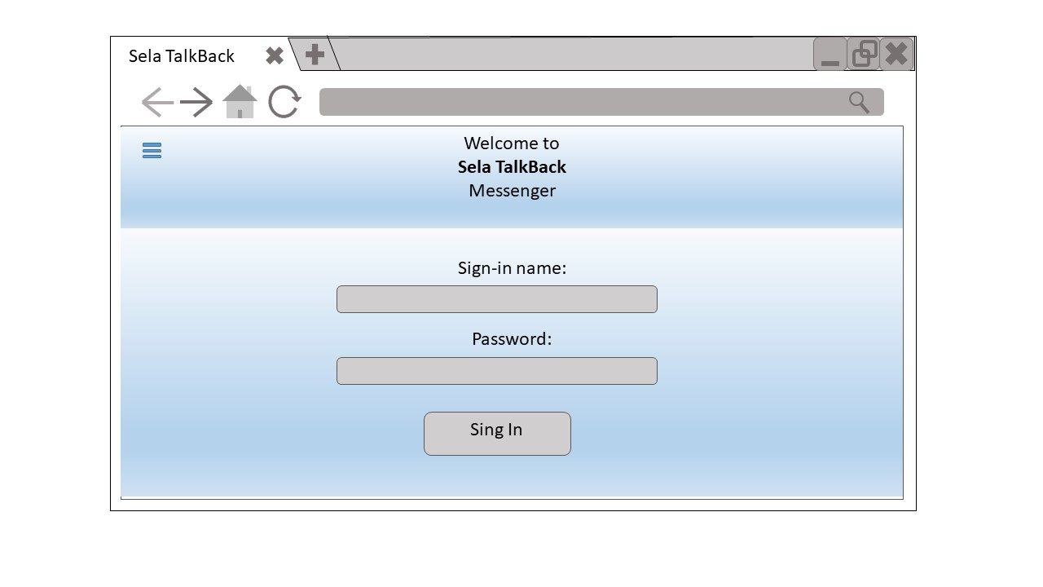
The title of this page is: "Sela TalkBack".
The top of the screen displays the following header: "Welcome to Sela TalkBack Messenger".
Below this is the sign-in area.
# | Object | Title | Type | Values | Functionality
1 | Page header | Sela TalkBack | Typical page title | - | Names the tab in browser
2 | Menu button | Three  horizontal  lines | Button | _ | Always enabled.  Upon selection, the menu will pop up from the right.  (See menu options below.)
3 | Sign-in border | Welcome to Sela TalkBack messenger | Border | - | -
4 | Sign-in | Sign-in name | Text box | None for a new user.  For an existing user, the username may appear highlighted. | Always enabled.  Displayed the characters entered by the user.
5 | Password | Password | Password box | None | Always enabled.  Displays the characters entered as dots.
6 | User sign-in | Sign in | Button | - | Enabled only if user entered name and password.  Upon selection, the client will attempt to connect to the server. If successful, the screen will change to the "contact screen".  If sign-in failed, a popup window will appear with the message: "Cannot connect now. Try again later."

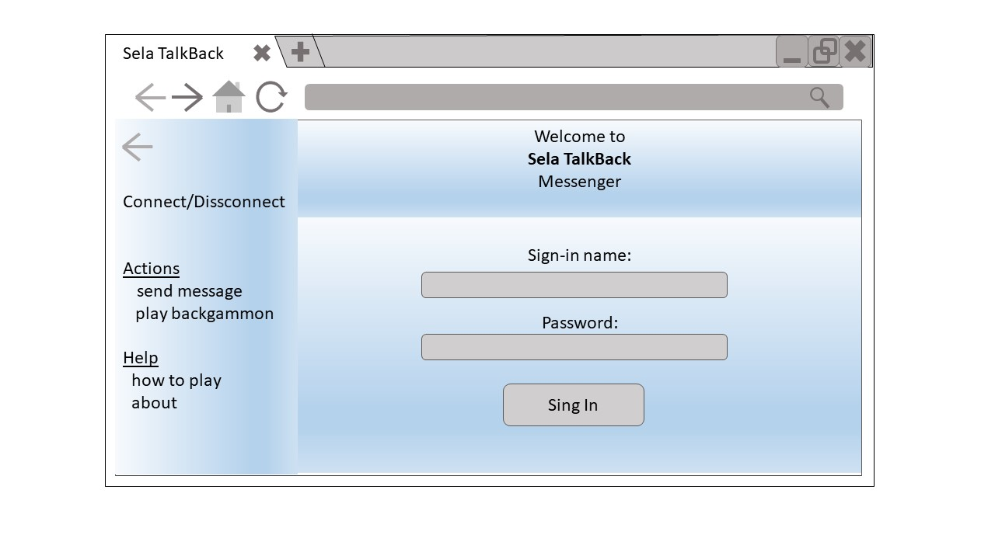
Menu options:

Option | Functionality
Connect / disconnect | "Connect" appears if the client is currently signed out. When selected, the client will sign in and the window should change to the "contact page".  "Disconnect" appears if the client is currently signed in. When selected, the client will sign out and the window should change back to the "sign-in page."
Actions | Enabled only if the user is signed-in.  Will have the following options below it:  Send Message – enabled only if a contact is highlighted in the list. Selecting this should be like pressing the chat button in the contact pane.  Play Backgammon – always enabled. Selecting this should be like pressing the game button in the contact pane.
Help | It should have these options below it:  How to play – launches a tutorial on how to play backgammon.  About – shows info about the program.

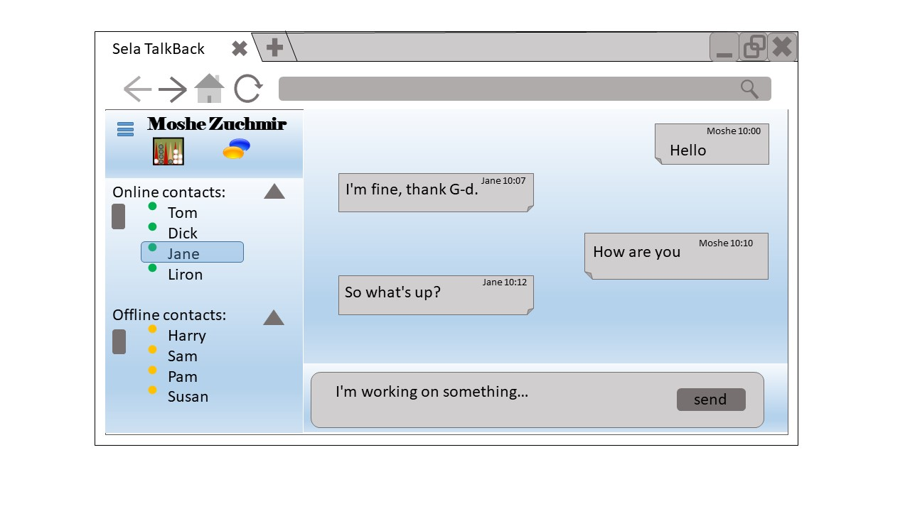
Contact pane

.
# | Object | Title | Type | Values | Functionality
1 | Page header | Sela TalkBack | Typical page title | - | Names the tab in browser
2 | User border | <Username> | Border | The current username should appear here | -
4 | Game button | Backgammon icon | Button | - | Always enabled.  Upon selection, the application will attempt to start a game of backgammon against a selected contact (if a contact's name is highlighted) or against a computerized player (if no contact is highlighted).
5 | Online Contacts area | Online contacts | List | Displays those contacts that are online with a green circle next to each name. | A contact name can be clicked. When clicked, the name will become highlighted and the chat button will become enabled.
6 | Onlline minimize arrow | Onlline minimize | Button |  | Always enabled  Upon selection , the list of online contacts will be minimized / expanded, and the arrow direction will flip horozontelly
7 | Offline Contacts area | Offline contacts | List | Displays those contacts that are offline with an orange circle next to each name. | -
8 | Offline minimize arrow | Offline minimize | Button |  | Always enabled  Upon selection , the list of offline contacts will be minimized / expanded, and the arrow direction will flip horozontelly

Chat pane
# | Object | Title | Type | Values | Functionality
1 | Chat history area | - | Border | - | Read only. Displays the messages sent and received by the user, in order they were sent.  With name of sender and time displayed per messege
2 | Message composing area | - | Text area box | - | Here the user can write messages to send to his contact.
3 | Send button | Send | Button | - | Enabled only if there are any characters entered in the message composing area. When selected, the message will get sent to the contact, be erased from the composing area and appear in the chat history.  Note: pressing "enter" works in the same way.

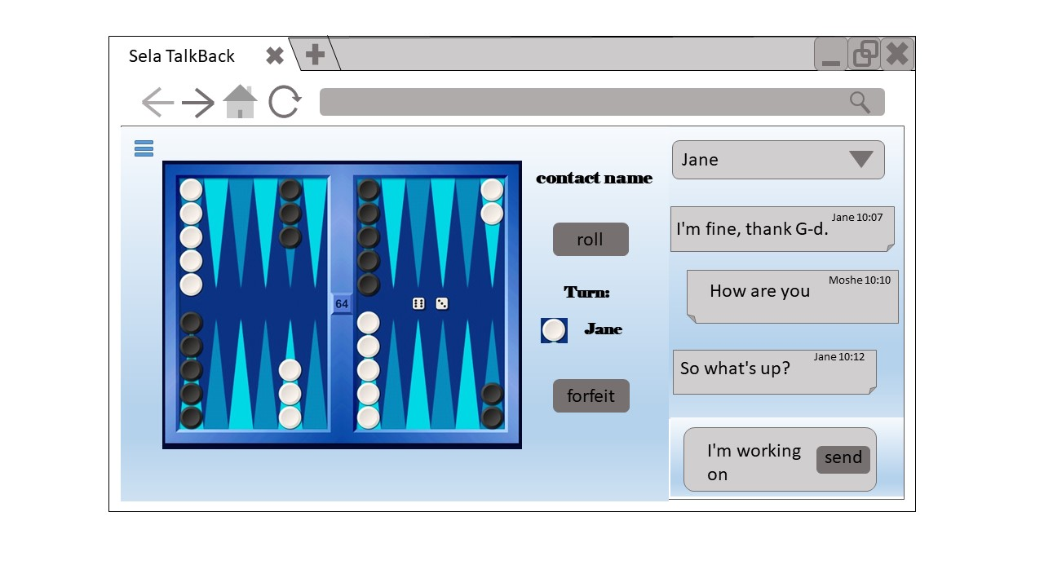
Game pane

# | Object | Title | Type | Values | Functionality
1 | Page header | Sela TalkBack | Typical page title | - - | Names the tab in browser
2 | Game border | - | Border |  | The game board appears here, with the pieces set up as in the beginning of a backgammon game (see illustration).  Playing pieces can be picked up and put down as defined in the game screen section.
3 | Game pieces | - | Icons | - | Only the pieces of the color the user is playing can be clicked. Enabled only when it is the user's turn. When clicked, the mouse pointer will change to the piece. Can be moved only to places legal in the game.
4 | Action border | - | Border |  | Appears to the right of the game board.  Should have player's name on the bottom, and opponents name on the top.  In addition an indication of who’s turn it currently is. Also has buttons for rolling and resigning.
5 | Roll button | Roll | Button | - | Enabled only at the beginning of a game or when opponent completed his turn. Upon selection:  - At the beginning of the game, one die should appear rolled on the right part of the game board.  - During the game, two dice should appear rolled on the right part of the board.
6 | Resign button | Resign | Button | - | Enabled only when the game has already started and it is the player's turn. Upon selection, a popup window will open, asking the user to confirm his resignation. If the user confirms, a different popup will notify him he lost the game. If he cancels, the popup window will close.

Cntact pane “narrow mode”

# | Object | Title | Type | Values | Functionality
1 | Current contact drop down selection button | Current contact | Button | All online contacts | Will display current contact user is chatting with.  On selection will display all current online contacts, and on selection chat will change to selected contact and chat history will be displayed.
2 | Chat history area | - | Border | - | Read only. Displays the messages sent and received by the user, in order they were sent.  With name of sender and time displayed per messege
3 | Message composing area | - | Text area box | - | Here the user can write messages to send to his contact.
4 | Send button | Send | Button | - | Enabled only if there are any characters entered in the message composing area. When selected, the message will get sent to the contact, be erased from the composing area and appear in the chat history.  Note: pressing "enter" works in the same way.

